|  |  |  |  |
| --- | --- | --- | --- |
| Document Name | Version | Prepared by | Reviewed by |
| J meter configuration with Jenkins | Apache jmeter5.4 | Rakesh Paliwal | Sumit malhotra |
|  |  |  |  |

How to install and configure jmeter with jenkins

Contents

How to install and configure jmeter with jenkins 1

How to run JMeter with Jenkins 1

How to install the Jenkins and JMeter plugin 2

How to run a JMeter test in Jenkins 2

How to use the Performance Plugin 4

[How to run JMeter with Jenkins](https://wiki.jenkins.io/display/JENKINS/How+to+run+JMeter+with+Jenkins)

1. [Dashboard](https://wiki.jenkins.io/collector/pages.action?key=JENKINS&src=breadcrumbs-collector)

[Skip to end of banner](https://wiki.jenkins.io/display/JENKINS/How+to+run+JMeter+with+Jenkins#page-banner-end)

[Go to start of banner](https://wiki.jenkins.io/display/JENKINS/How+to+run+JMeter+with+Jenkins#page-banner-start)

[Skip to end of metadata](https://wiki.jenkins.io/display/JENKINS/How+to+run+JMeter+with+Jenkins#page-metadata-end)

* Created by Unknown User (tejaswiniul), last modified on [Feb 04, 2017](https://wiki.jenkins.io/pages/diffpagesbyversion.action?pageId=104759410&selectedPageVersions=3&selectedPageVersions=4)

[Go to start of metadata](https://wiki.jenkins.io/display/JENKINS/How+to+run+JMeter+with+Jenkins#page-metadata-start)

Continuous integration is an essential part of the software development lifecycle, and performance monitoring is a key part of continuous integration. We will learn how to set up performance monitoring with the popular [Jenkins automation server](https://jenkins.io/), and [Apache JMeter](http://jmeter.apache.org/) load and performance tester.

[Continuous integration](https://en.wikipedia.org/wiki/Continuous_integration) (CI) systems orchestrate and automate software build, testing, and deployment processes. CI systems:

1. Monitor source code repositories.
2. Run builds whenever code changes are detected.
3. Run tests against compiled software (unit, acceptance, automated, performance, integration).
4. Generate artifacts (binaries, documentation, installation packages).

How to install the Jenkins and JMeter plugin

If you don't already have [Jenkins](http://mindmajix.com/jenkins-training) installed, follow these steps to get up and running quickly.

1. Download the[latest Jenkins release](https://jenkins.io/) (the *.war* file should be enough).
2. Run Jenkins as **java -jar jenkins.war** and wait for the "Jenkins is fully up and running" message.
3. Open [http://localhost:8080](http://localhost:8080/) in your web browser.
4. You should now be able to see the Jenkins dashboard.

To get JMeter support on Jenkins, you need to use the Performance Plugin. Here is how:

1. Download the [latest version of the plugin|../../../../../../../../../display/JENKINS/Performance+Plugin\](https://wiki.jenkins.io/display/JENKINS/How+to+run+JMeter+with+Jenkins).
2. Copy the *performance.hpi* file to the *plugins* folder of your Jenkins installation. If you run Jenkins from the *.war* file, copy the plugin to the *.jenkins/plugins* path under your home folder.
3. Restart Jenkins to detect and load the plugin.
4. If the installation is correct you should see the **Publish Performance Test Result Report** option under **Jenkins -> Your Project -> Configure -> Add post-build action** dropdown.  
   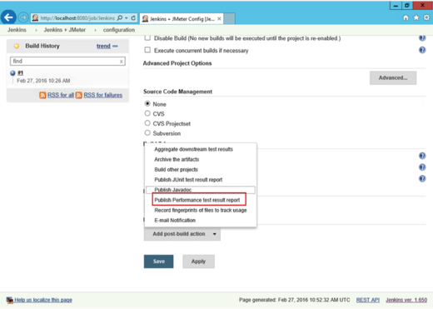

How to run a JMeter test in Jenkins

Running a JMeter test in Jenkins isn't very complex. Just remember that the test has to be run in from the command line. For your first couple of runs, you should configure JMeter to store its results in an XML format:

1. Add the*jmeter.save.saveservice.output_format=xml* line to the *user.properties* file in the */bin* folder of your JMeter installation.
2. Pass the property via the -J command-line argument, such as: **C:\jmeter\bin\jmeter.bat -Jjmeter.save.saveservice.output_format=xml -n -t C:\jmeter\extras\Test.jmx -l Test.jtl**

Here is how it looks when the Windows batch is configured to command to run a JMeter test:

*jmeter.save.saveservice.output_format=xml* line to the *user.propertie*

/opt/apache-jmeter-5.4/bin/jmeter.sh -Jjmeter.save.saveservice.output_format=xml -n -t /opt/apache-jmeter-5.4/extras/Test.jmx -l Test.jtl

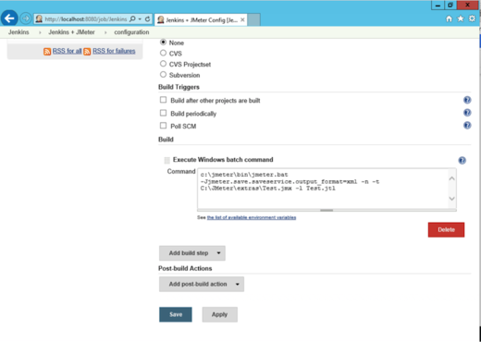

To verify the execution was successful, or to get extra information regarding any problems, check the **Console Output** tab of the project.

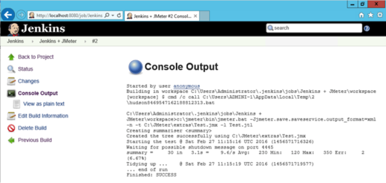

You can find the JMeter log file and the *.jtl* results file under your project's **Workspace**.

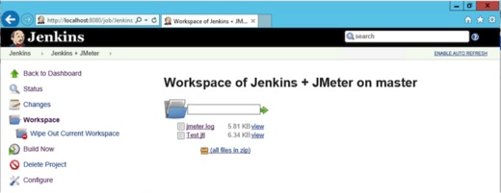

How to use the Performance Plugin

The Performance Plugin displays statistics, trends and can be used to mark builds as failed based on results. Follow these steps to add it to your project:

1. Open the Jenkins project.
2. Click the **Configure** button.
3. Click the **Add post-build action** button.
4. Select **JMeter** to output results in XML format.

Now you have automated your performance testing, and can spend more time on improving your software instead of struggling with identifying performance problems.